# Welcome to the Qumulo Core Tutorials

Qumulo Core is scale-out network attached storage (NAS) that lets you not just store your data but manage it. You can take store and control multiple petabytes of data and billions of files. For example, Qumulo Core’s real-time analytics gives you immediate visibility into what’s happening in your file system. You can set directory quotas that take place instantaneously. Replication and snapshots let you backup and restore earlier states, in case of problems.

This set of tutorials will show you how to set up a Qumulo Core cluster and will familiarize you with some of the Qumulo Core features.

Let’s get started by creating a cluster. First, select whether you want to set up a simulated cluster on your machine or an actual cluster in the cloud.

Use a VMware virtual cluster.

Use AWS (you’ll need an AWS account).

# Create a Qumulo Core Virtual Cluster

In this tutorial, you’ll simulate an on-premises Qumulo Core cluster by using VMware virtual machines (VM) to create 4 nodes. A *cluster* is a collection of *nodes*, where an on-premises node is a single hardware chassis (simulated in the tutorial by a VM). An on-premises cluster requires a minimum of four nodes because of the way the block protection scheme works.

## System requirements:

Here are the hardware and software requirements.

For best performance, we ecommend that your computer have at least 8GB of RAM and an SSD to host the virtual images.

You need VMware Fusion installed.

You need access to the Internet.

We recommend that you use the Chrome browser.

## User requirements

The tutorials walk you through everything you need to know to set up and use a cluster but it’s helpful if have some understanding of the network you’ll be using. Try to find out if your environment uses the Dynamic Host Configuration Protocol (DHCP) to assign IP addresses or if you need to assign the addresses yourself. If you do need to assign the IP addresses manually, collect the following information:

* The subnet mask
* The gateway
* The IP addresses of the DNS servers
* The search domain(s)
* The maximum transmission unit (MTU)

Also, try to determine what kind of network connection you use (for example, bridged or network address translation (NAT)).

## Download the VM

In this section you download the VMs.

1. Download the VMware .ova file.
2. VMware Fusion opens. Select the qkiosk file and click Continue.
3. A dialog box opens. Enter the name of the image and where you want to save it. Click Save.
4. The name for the virtual machine is provided by default.
5. Enter a local storage path where you want to save the VM image. If possible, save it on an SSD device.

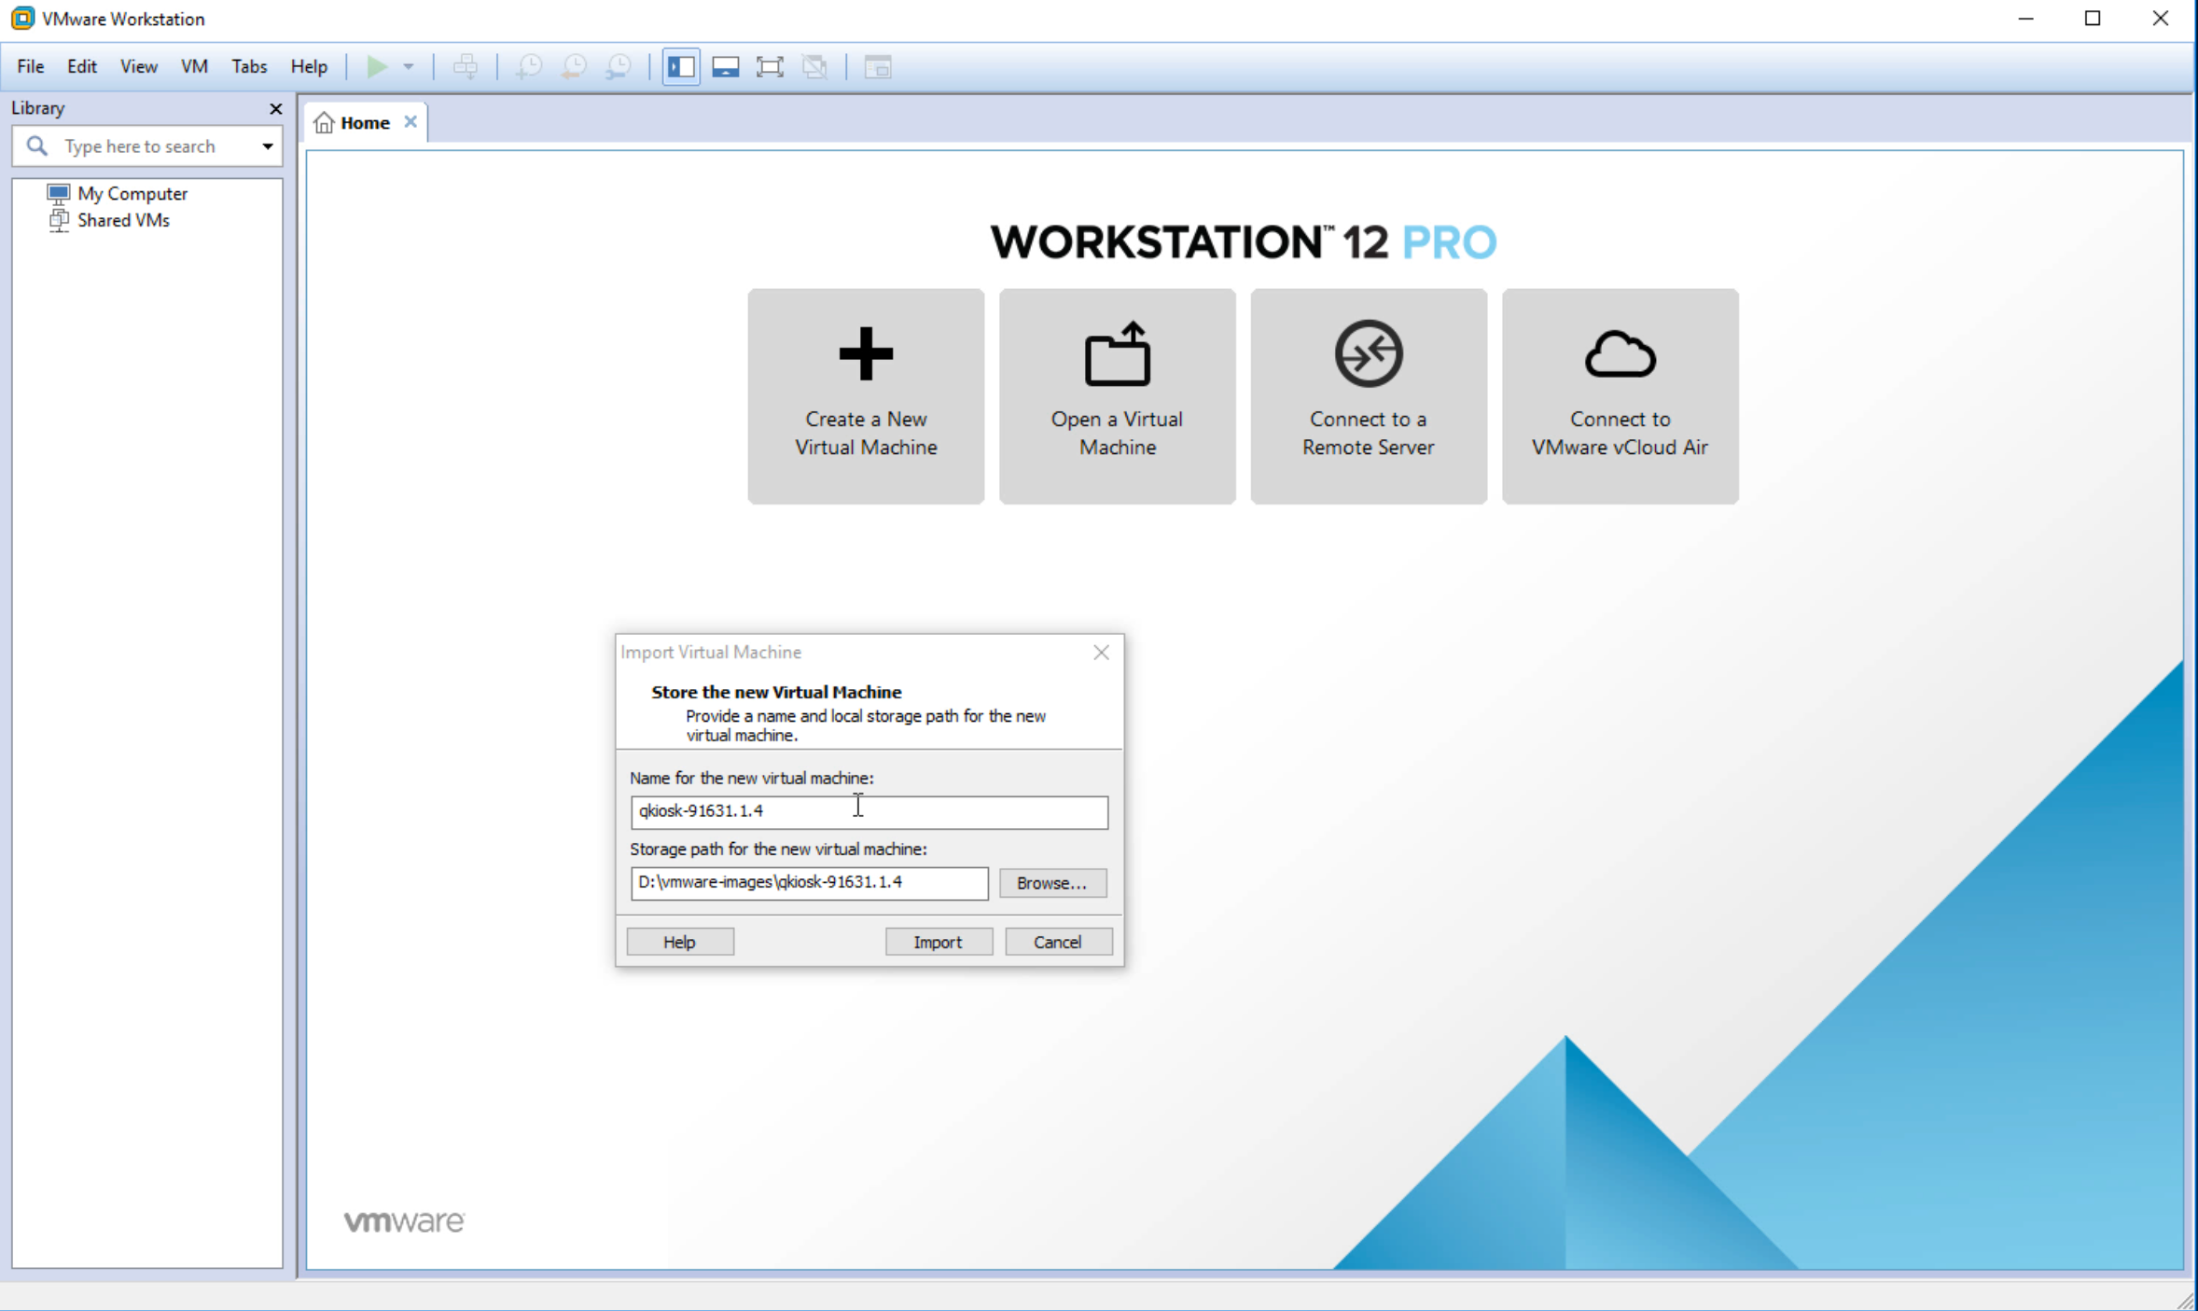

[initial vmware .ova launch]

1. Ignore the VMware Workstation warning and click **Retry**.

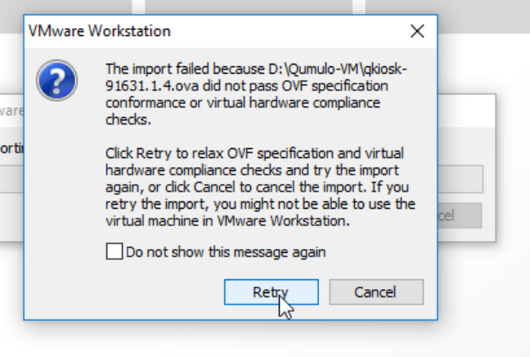

1. The progress bar appears. Wait for it to complete. Finish.

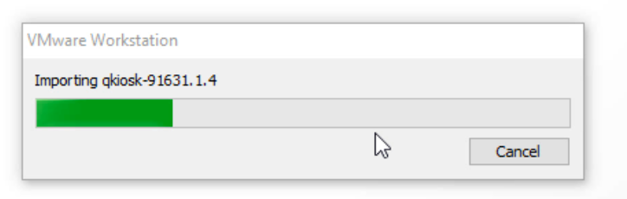

## Configure network settings

Once the image is downloaded, the VMware workstation dashboard appears. The instance should appear in the left pane, under My Computer.

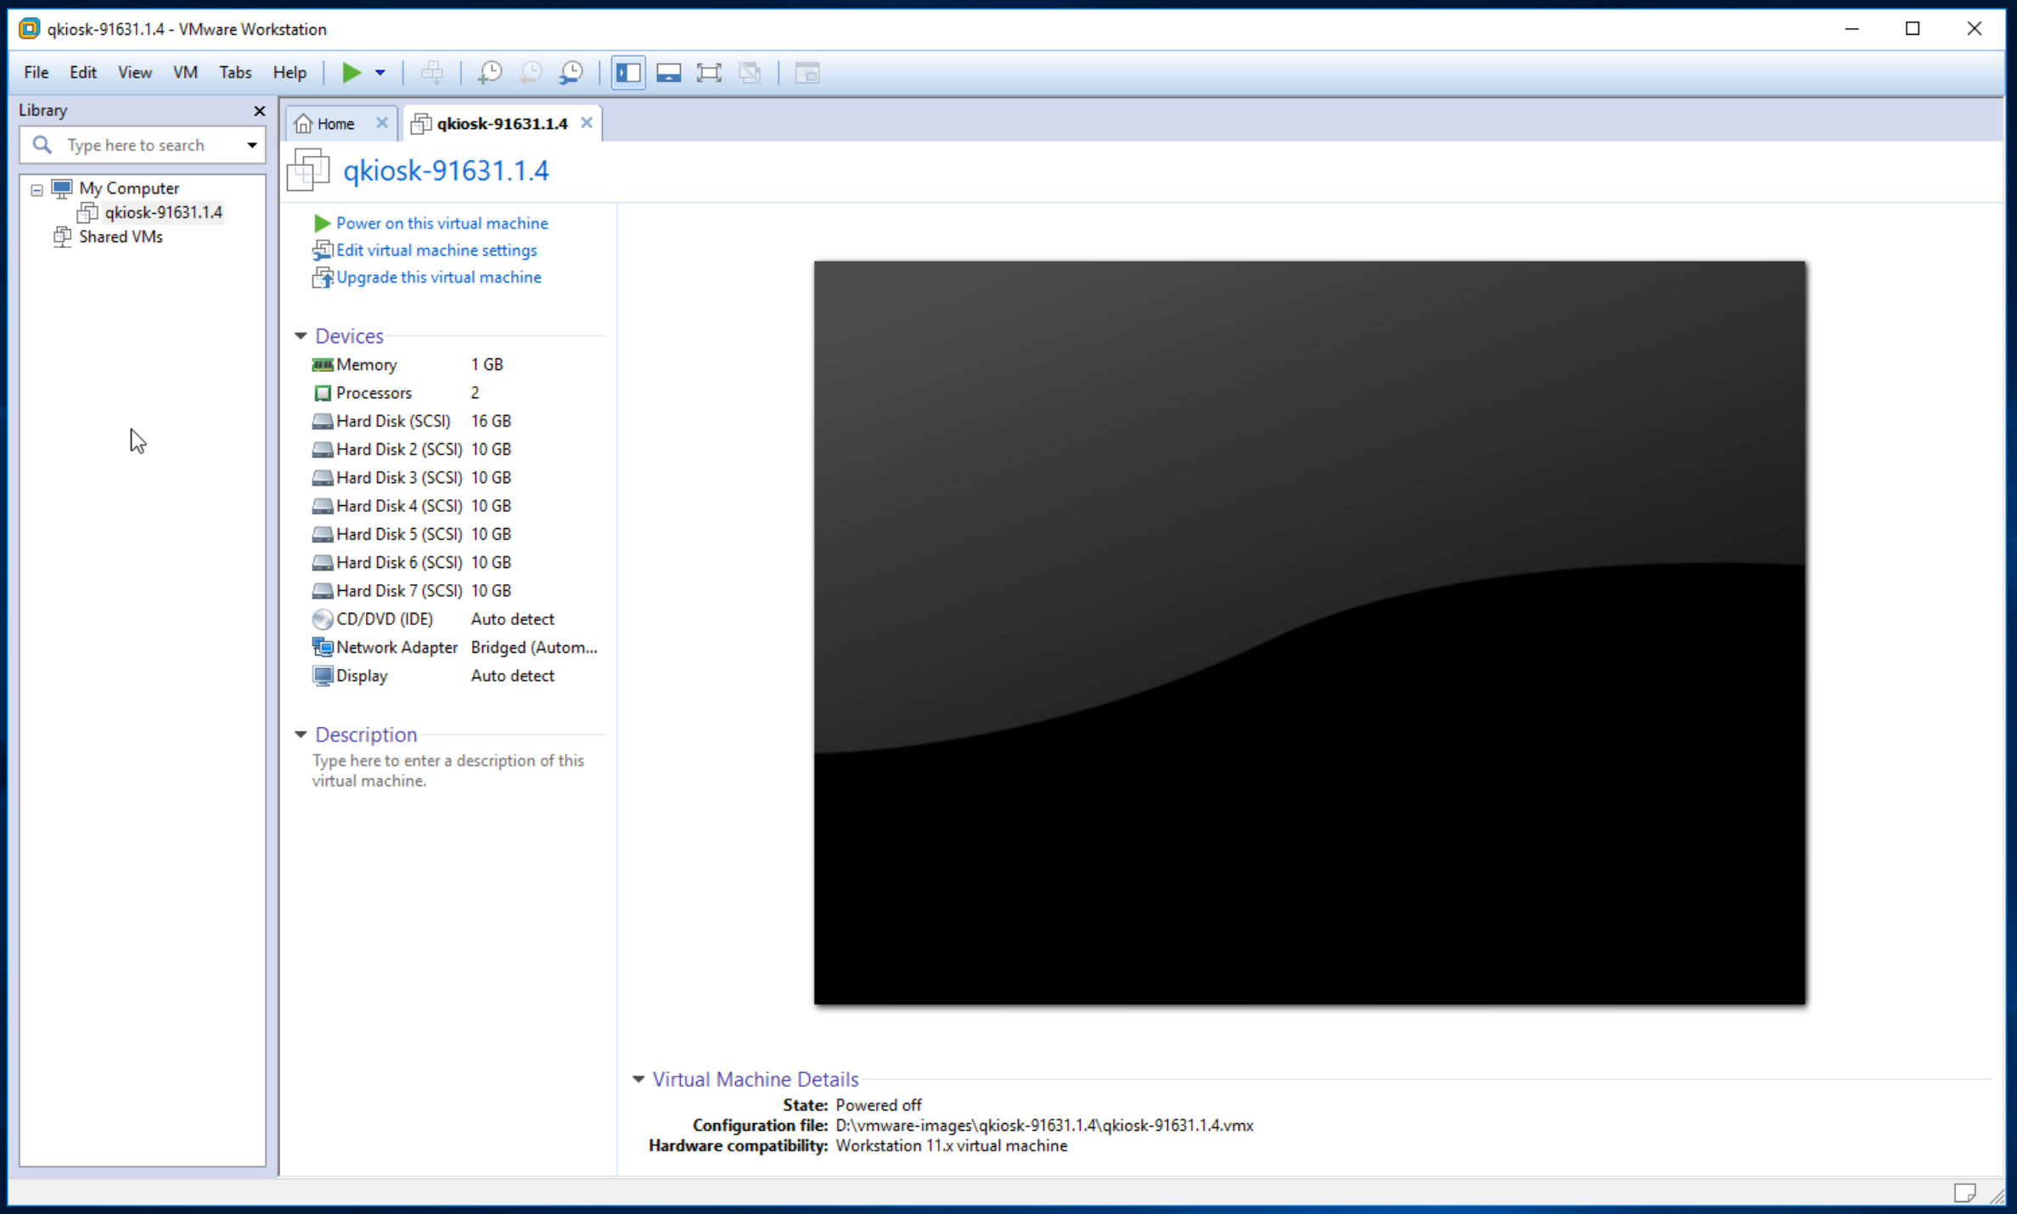

1. Click the instance.
2. Click Edit virtual machine settings. The Virtual Machine Settings window appears.

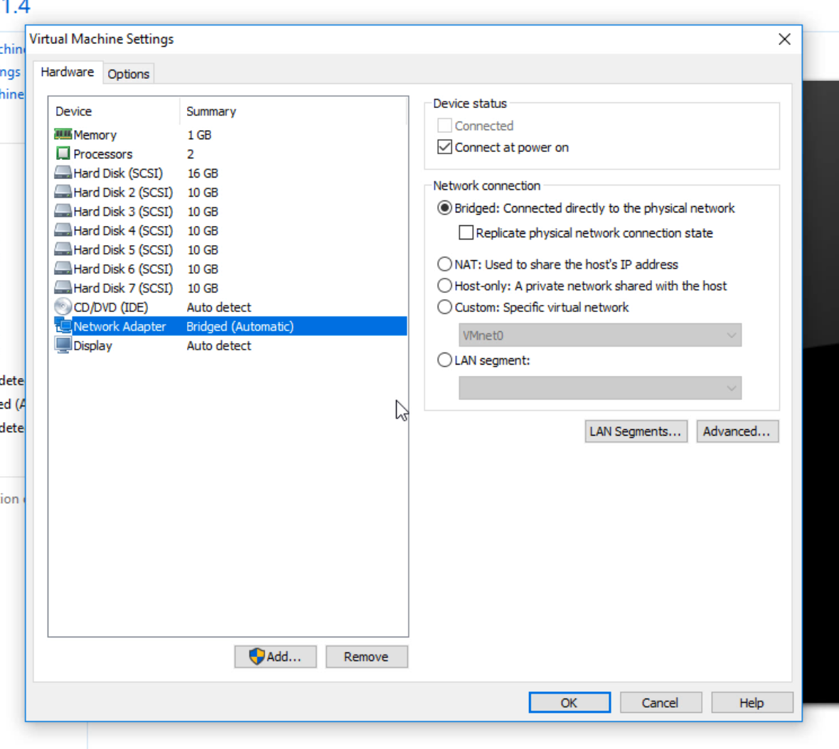

1. If you need to, select the Hardware tab.
2. In the left pane, click Network Adapter.
3. In the right pane, select the network connection you want to use.

Note: NAT uses the IP address of the machine that the VMs are running on and hide the internal IP addresses from your network. Bridged allows the virtual machines to present themselves as additional network interfaces.

If your environment uses DHCP then the VMs will automatically be assigned IP addresses. Otherwise, you’ll need to assign the IP addresses yourself. We’ll cover this later in the tutorial. (You can always changes these settings but you’ll need to restart the VMs.)

## Create three more VMs

You need to create three more VMs to complete your cluster. Follow the same steps as you did for the first instance. Each VM is automatically given a name and all the images are stored in the path you specified.

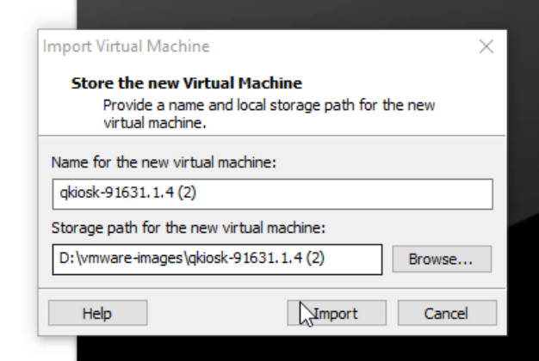

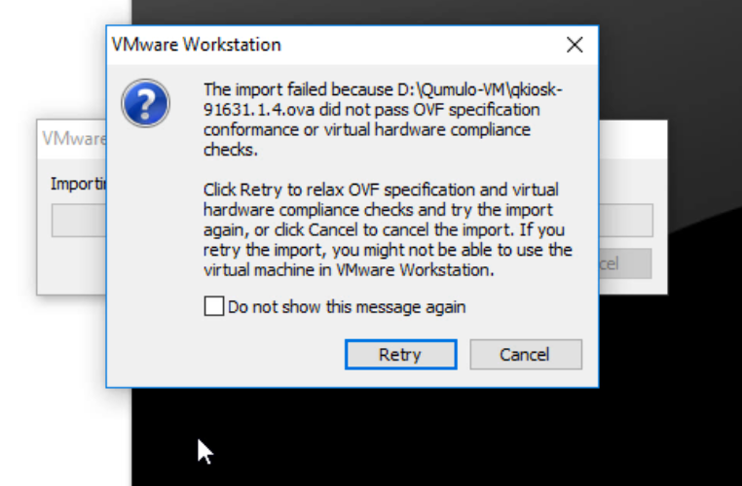

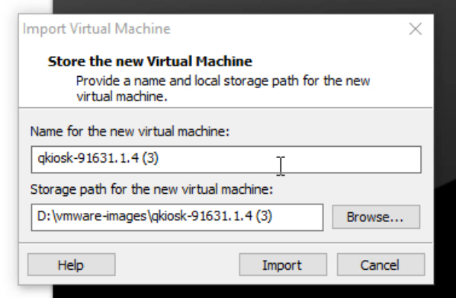

[instance #3]

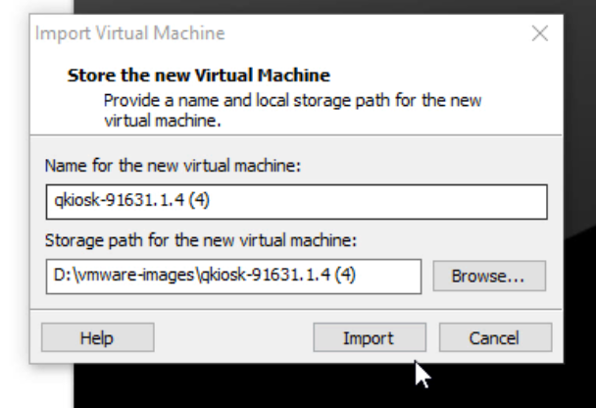

## Power on the VMs

In this section, you power own each of the four VMs.

1. In the VMware workstation, under My Computer, you should see all four instances listed.

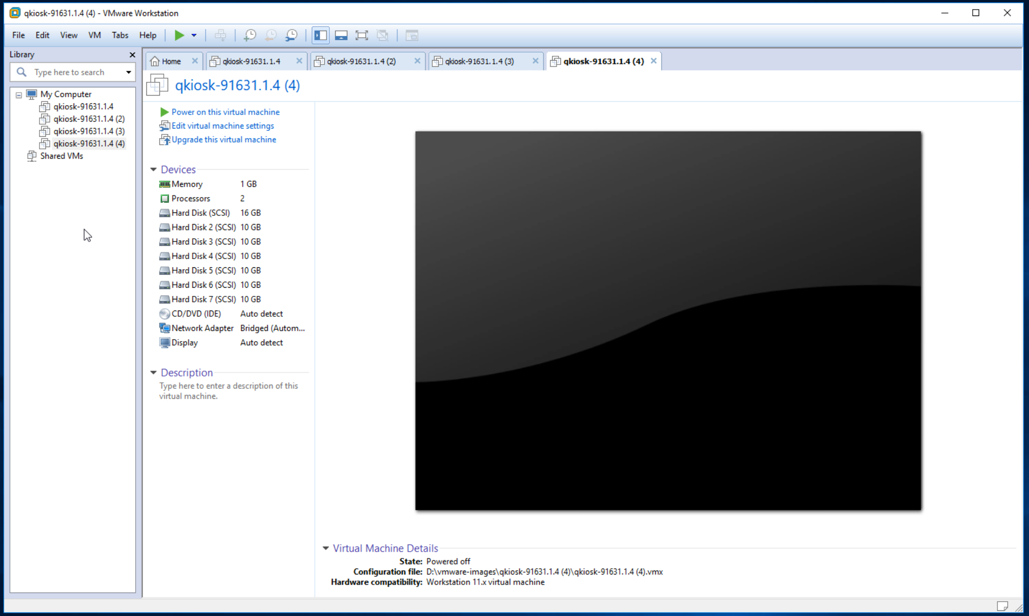

1. Click the first instance in the list and then click Power on this virtual machine.

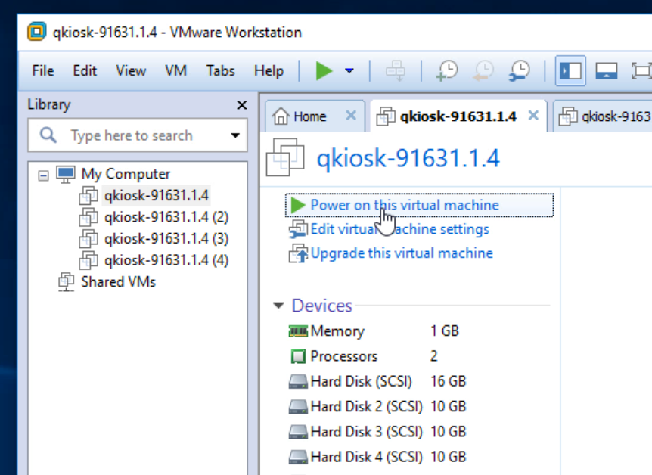

1. After a few seconds, the End User License Agreement (EULA) appears.

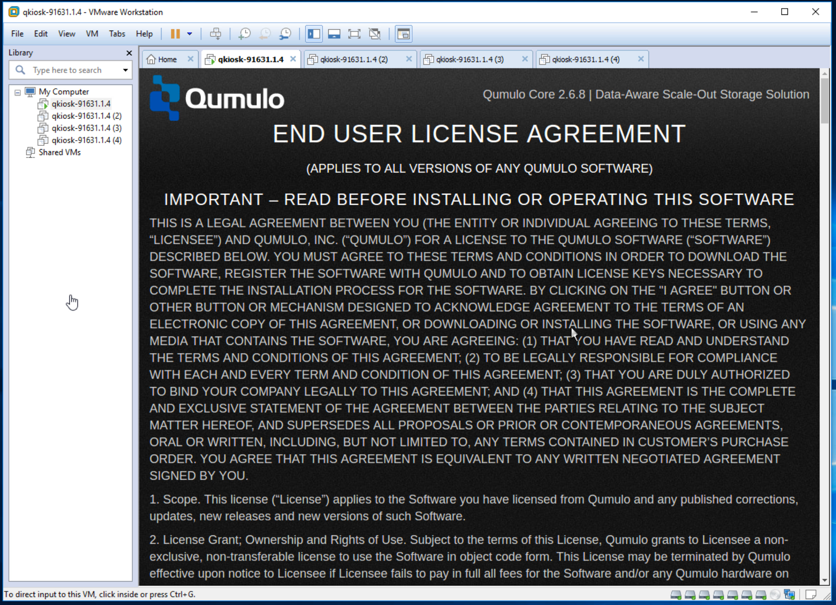

1. Scroll down, select both boxes, and click Submit.

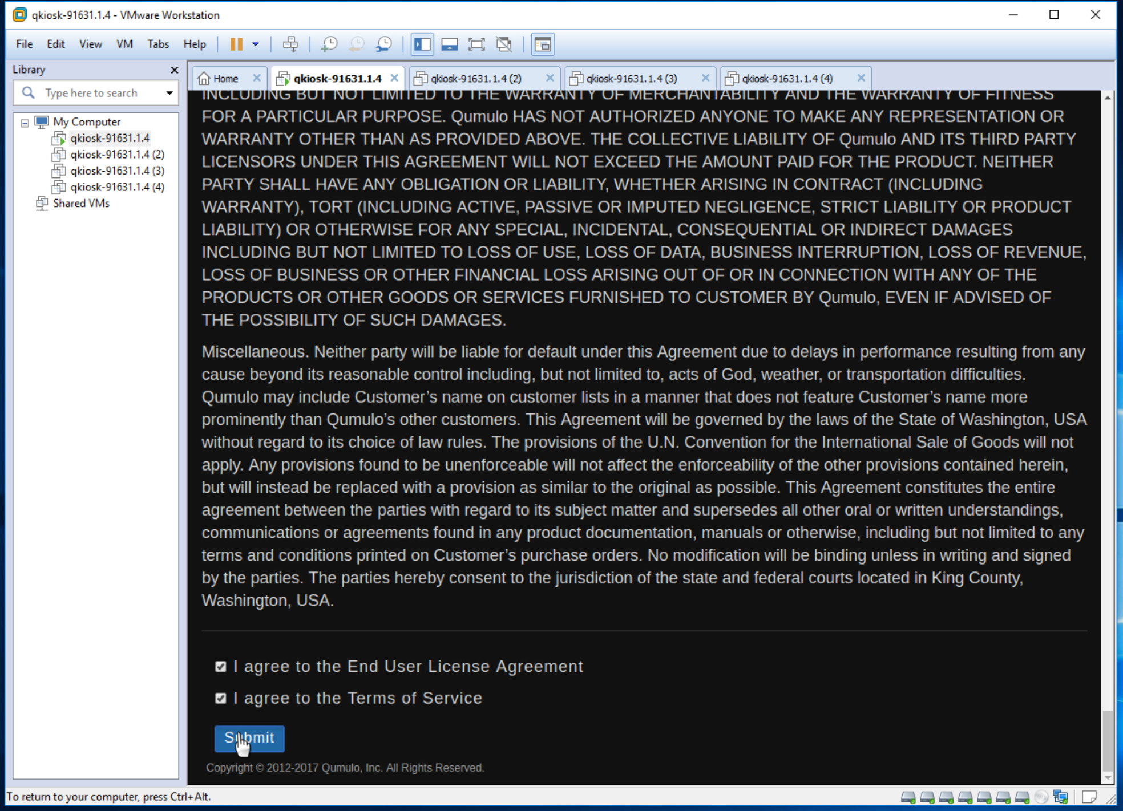

1. You should see the initial cluster configuration screen.

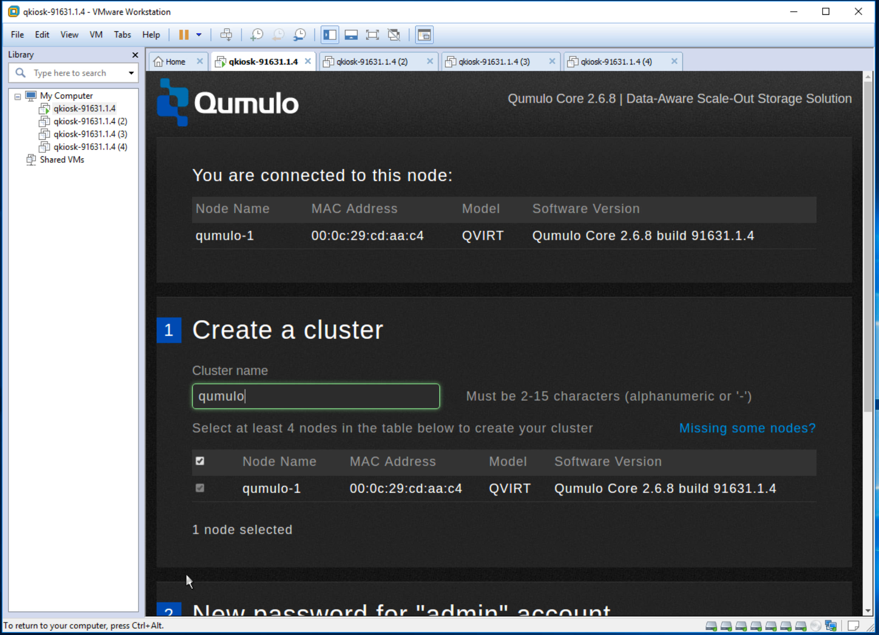

1. Follow the same steps to power on the remaining three instances.

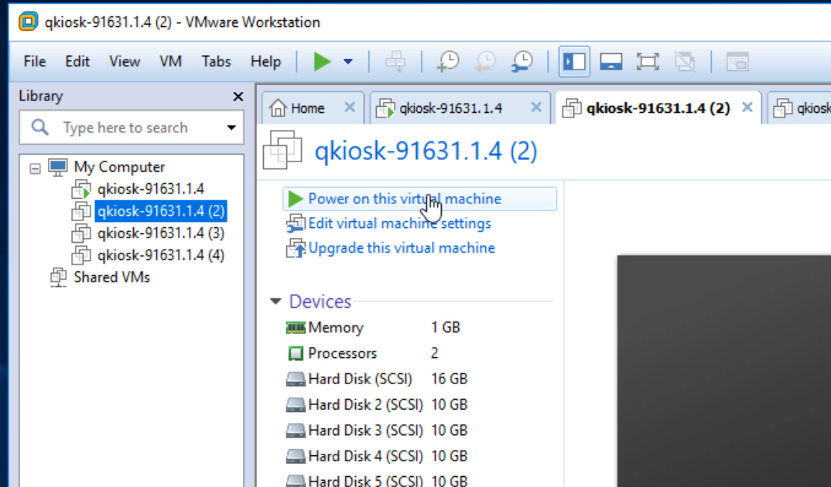

## Create the cluster

In this section, you create the cluster.

1. In the VMware Workstation, click the first instance listed under My Computer.

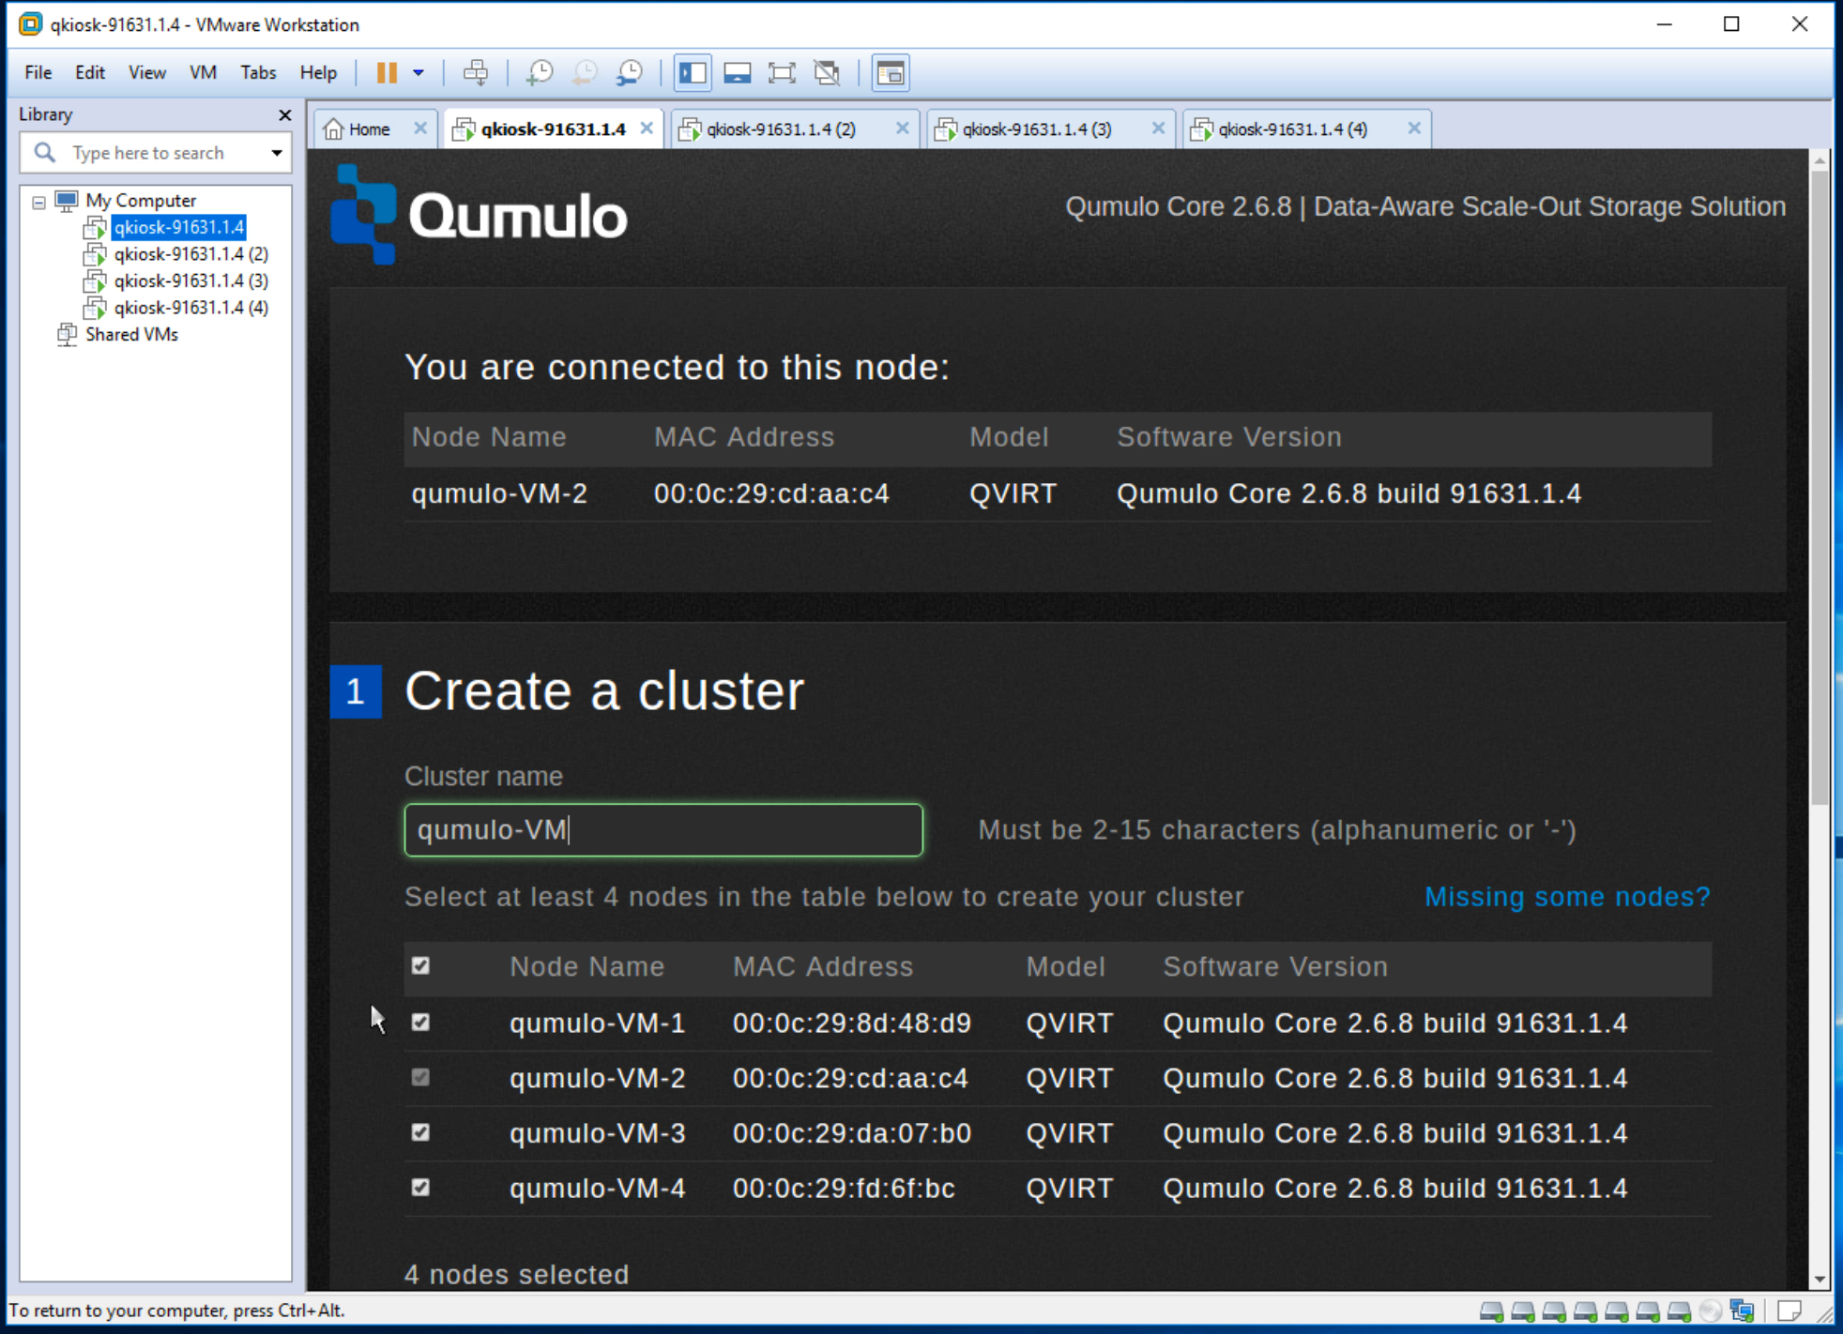

1. In the cluster name field, enter a name for your cluster. In this example, the name is qumulo-VM.
2. Scroll down to Username to set the password for the admin account. Make a note of it.

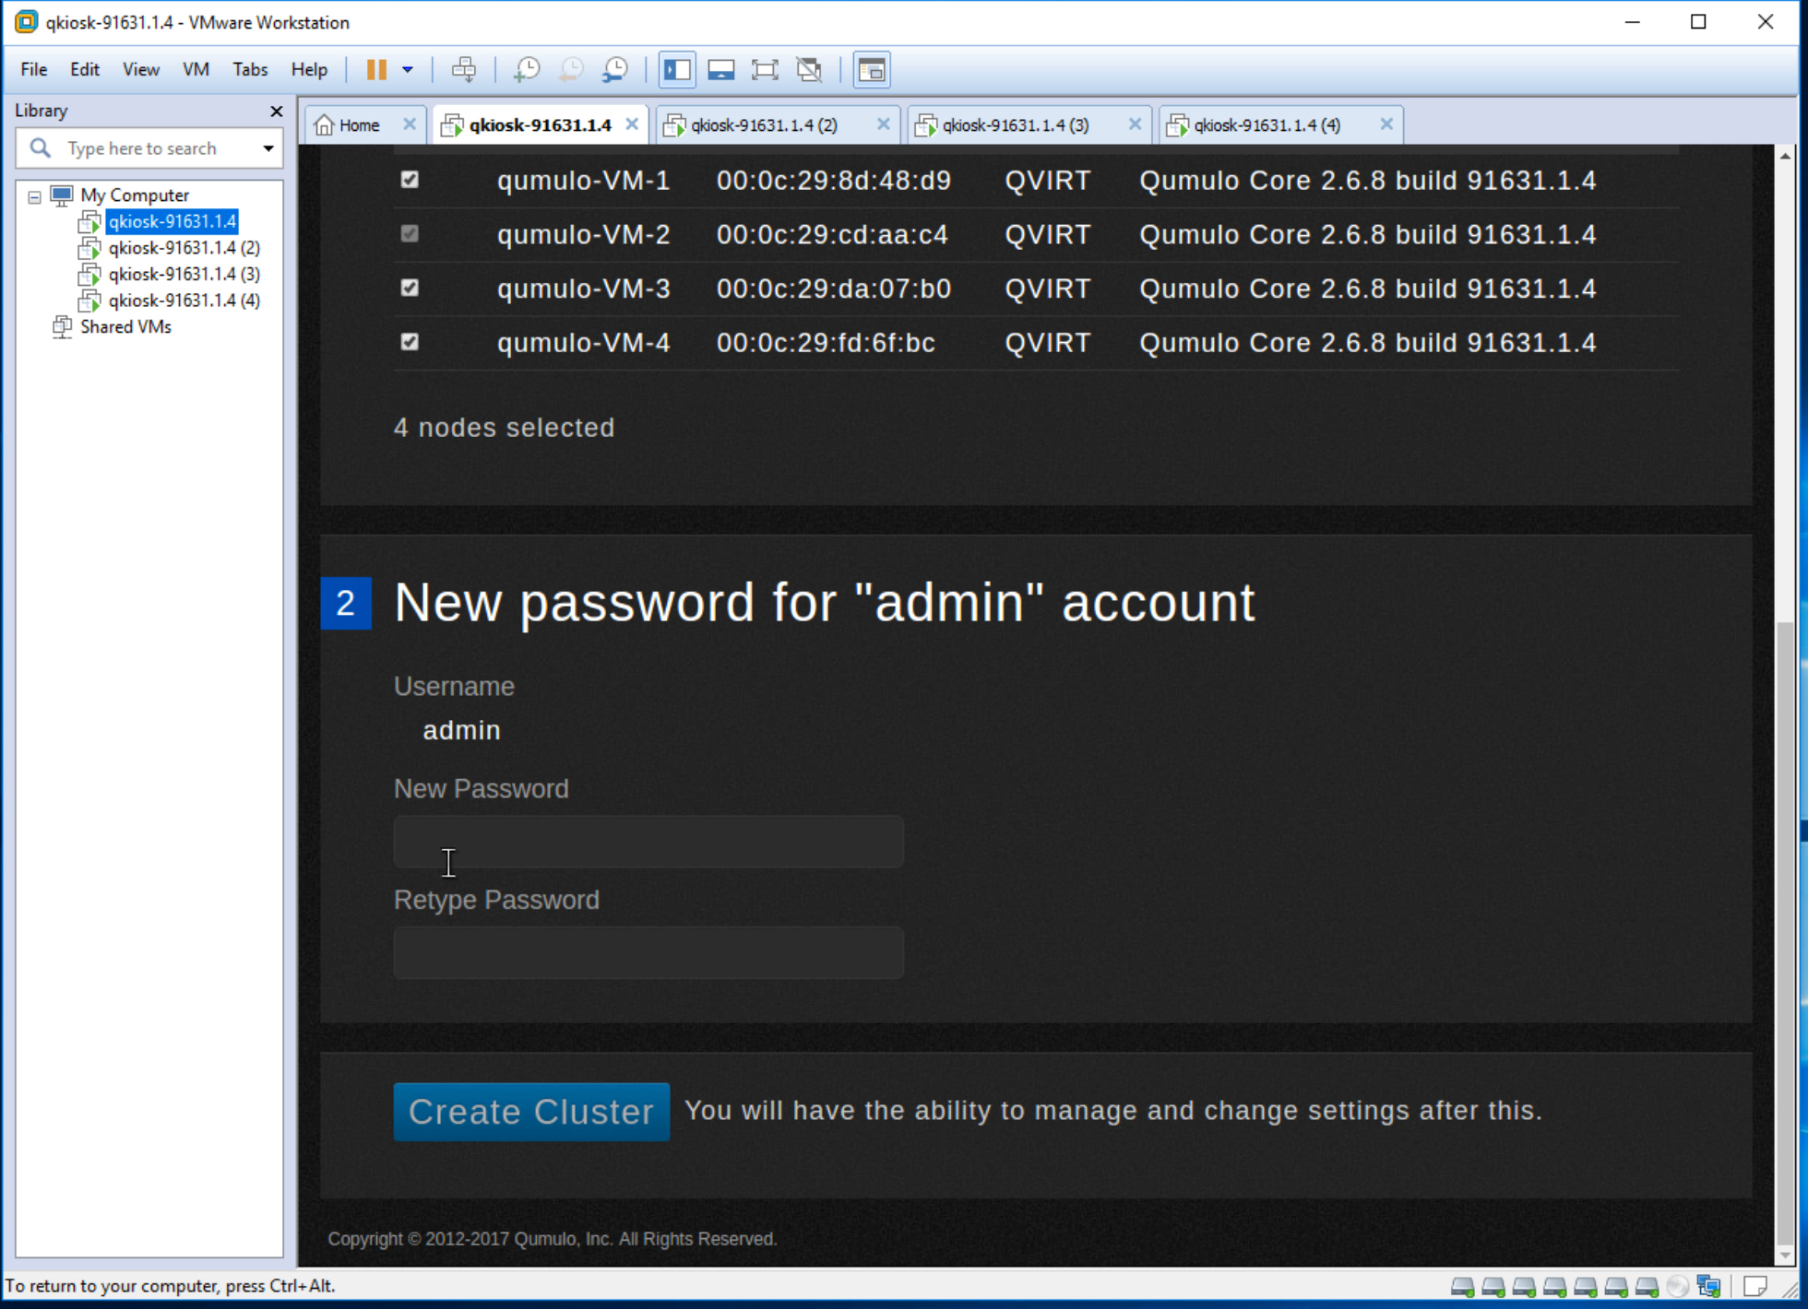

1. Click Create cluster.

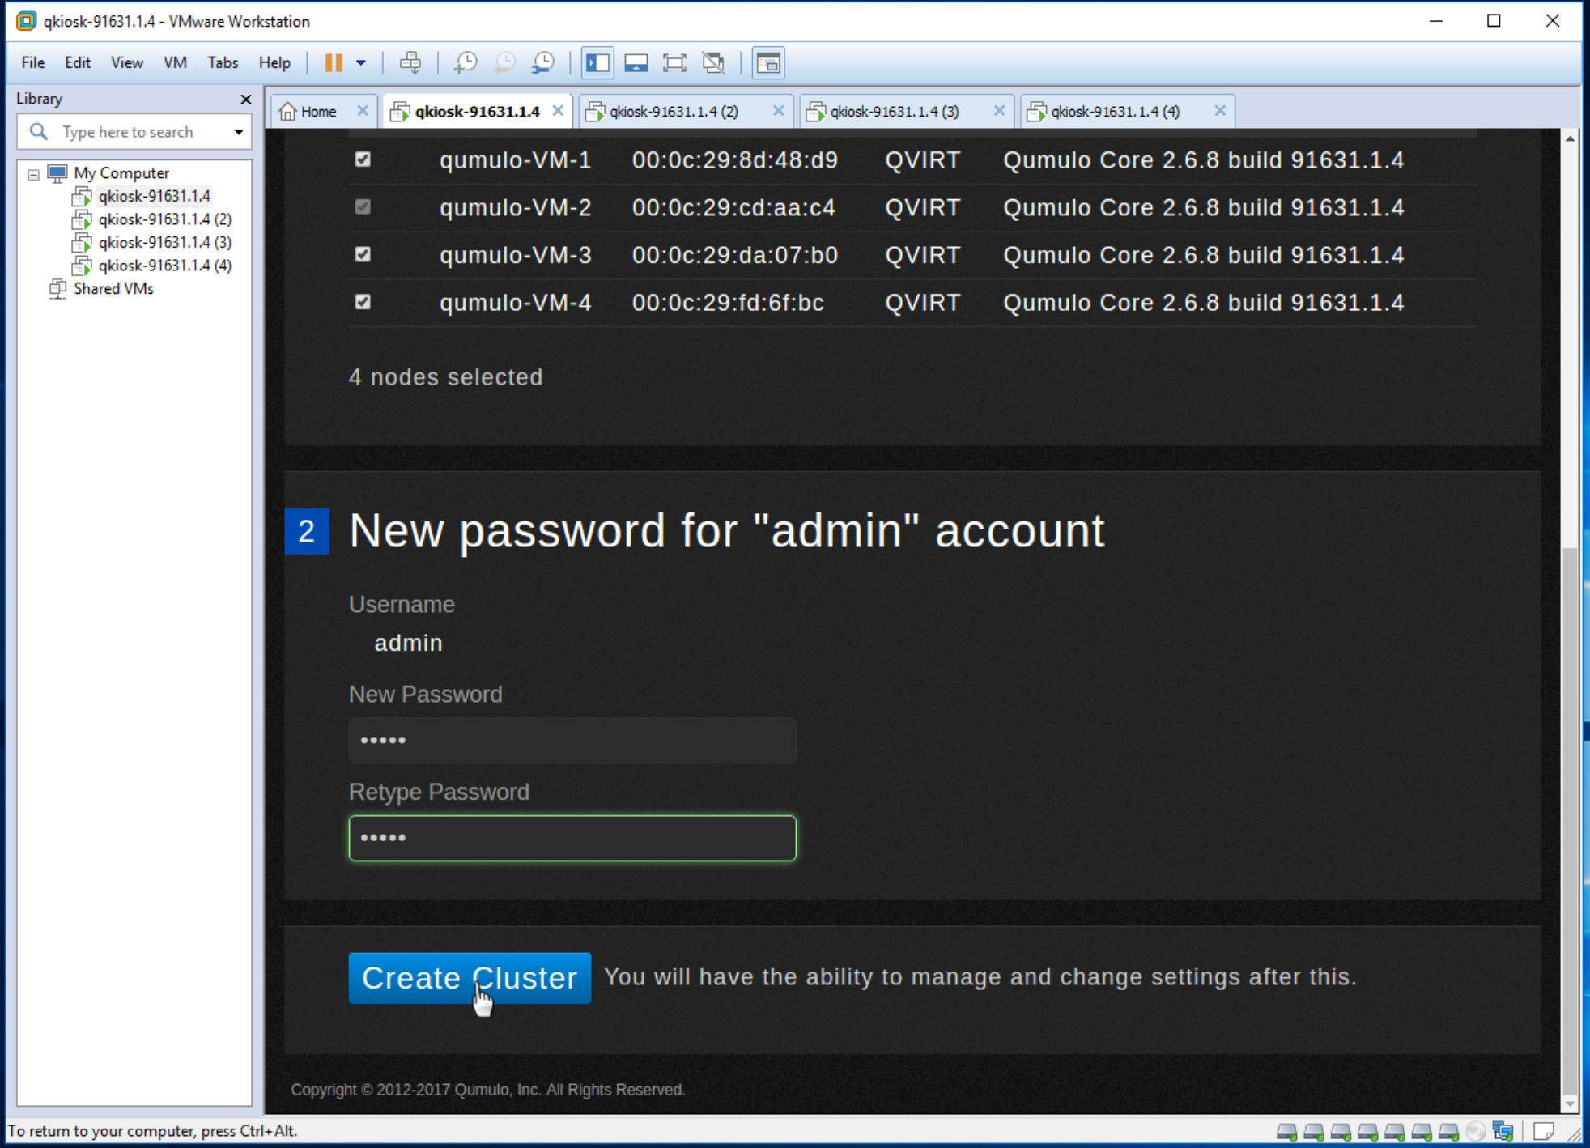

1. A dialog box asks for verification. Click Yes, Create Cluster.

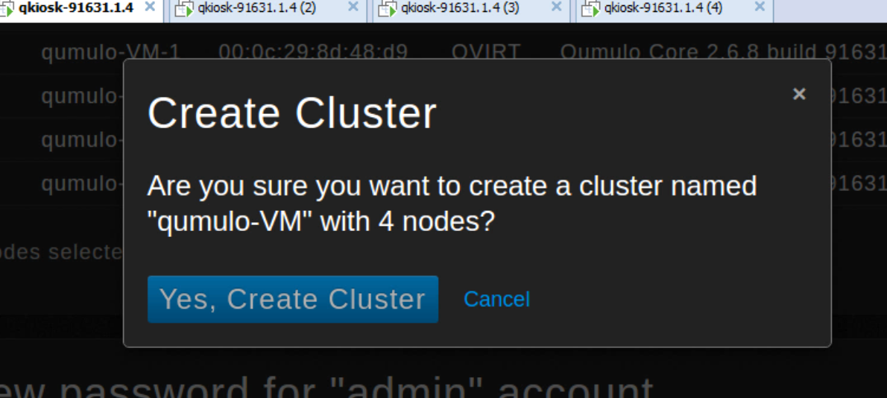

1. You should see the cluster being created:

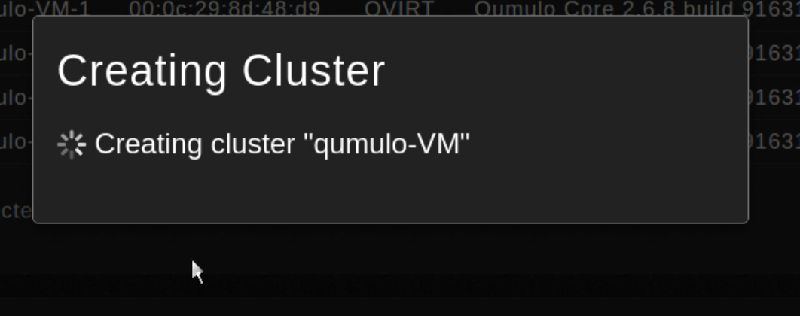

1. After a few seconds you should see the main cluster admin page:

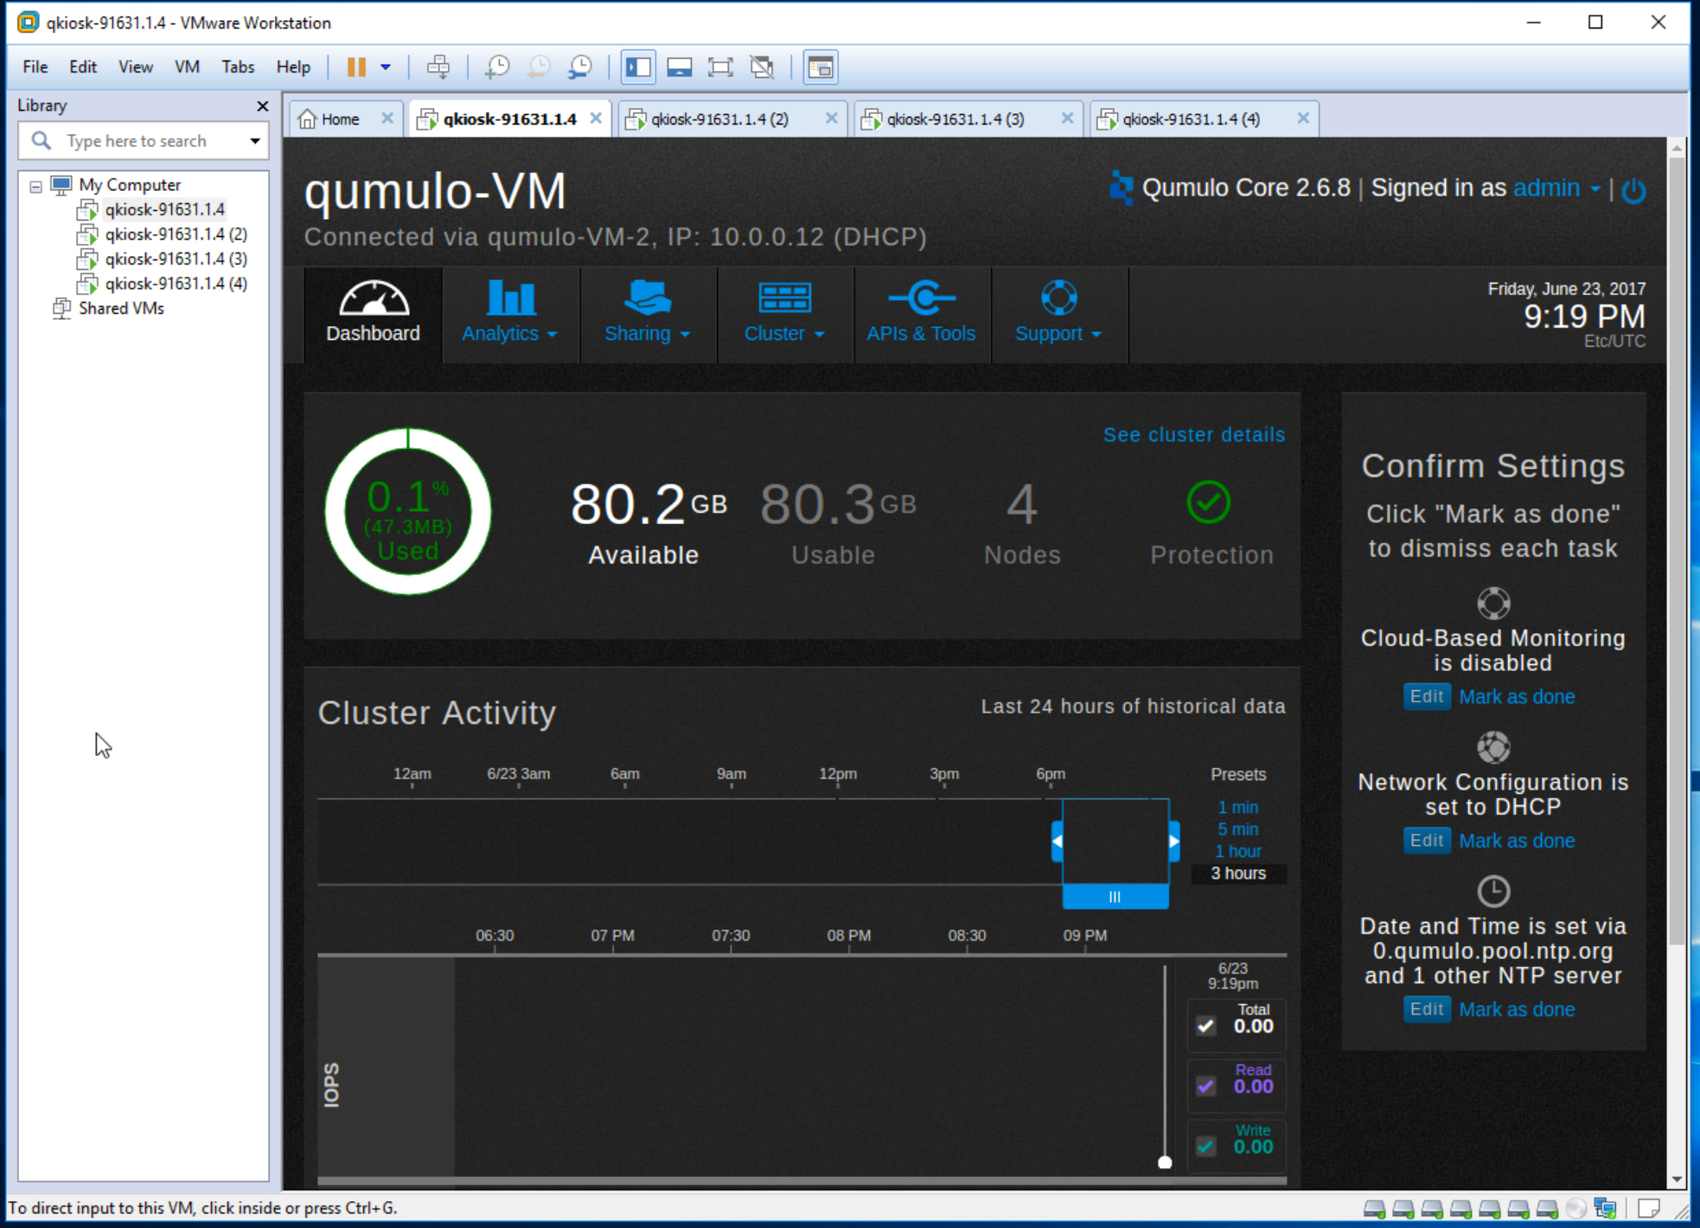

1. If DHCP is available, then the cluster self-assigns IP addresses. In this example, the first node has an IPv4 address of 10.0.0.12. You can use this address to access the Qumulo Core dashboard in your browser.
2. If you use DHCP then congratulations, you’ve set up your cluster. Skip the following section and go to What’s next? If you don’t use DHCP go to the following section, Assign IPv4 static IP addresses.

## Assign IPv4 static IP

Follow the steps in this section if you don’t use DHCP.

1. In the Dashboard top bar, click Cluster. Click Network Configuration in the menu.

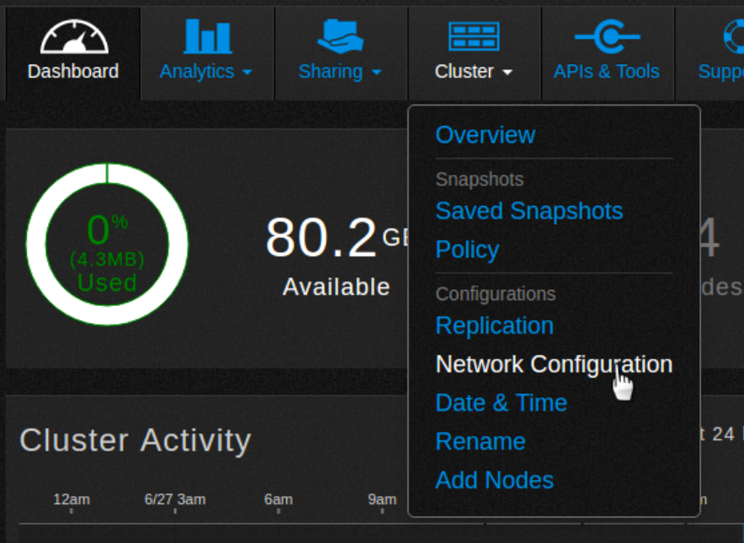

[network-configuration]

1. The Network Configuration IPv4 page appears. Fill in the the subnet mask, gateway, DNS servers, and Search Domains files. If necessary, change the MTU size.

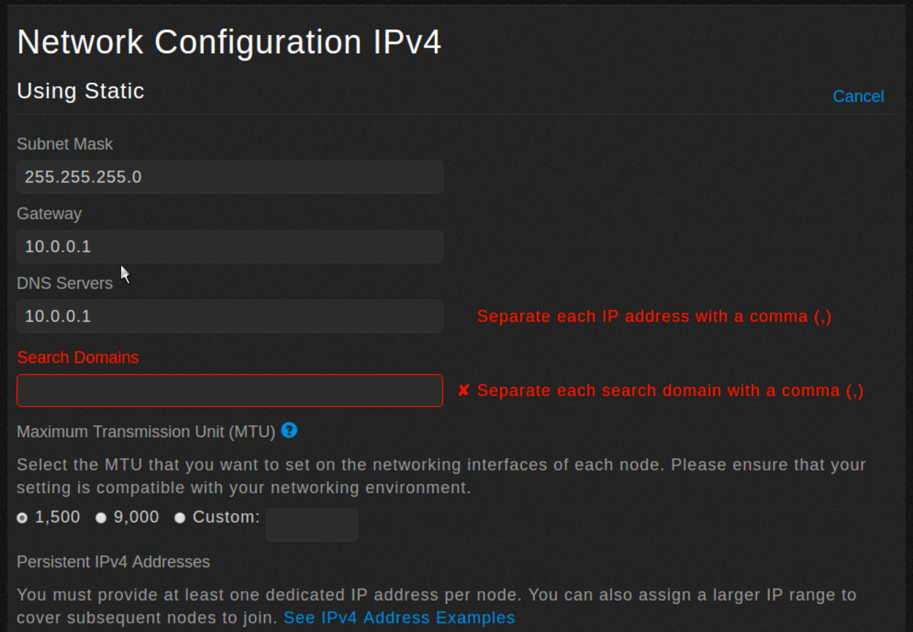

1. Scroll down and set the static IP addresses for each node.

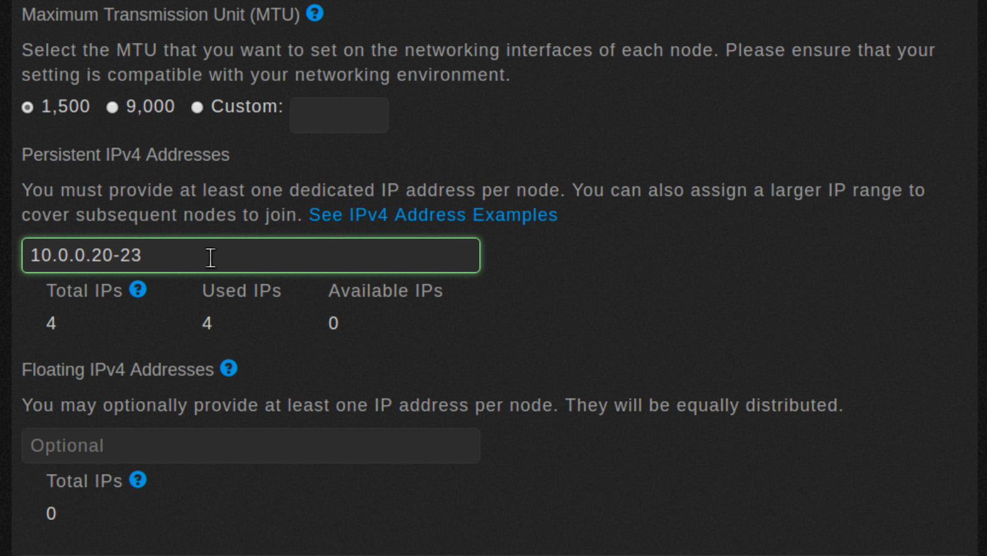

Optionally, you can assign floating IP addresses that will be redistributed in case a node fails.

1. Scroll down and click Save.

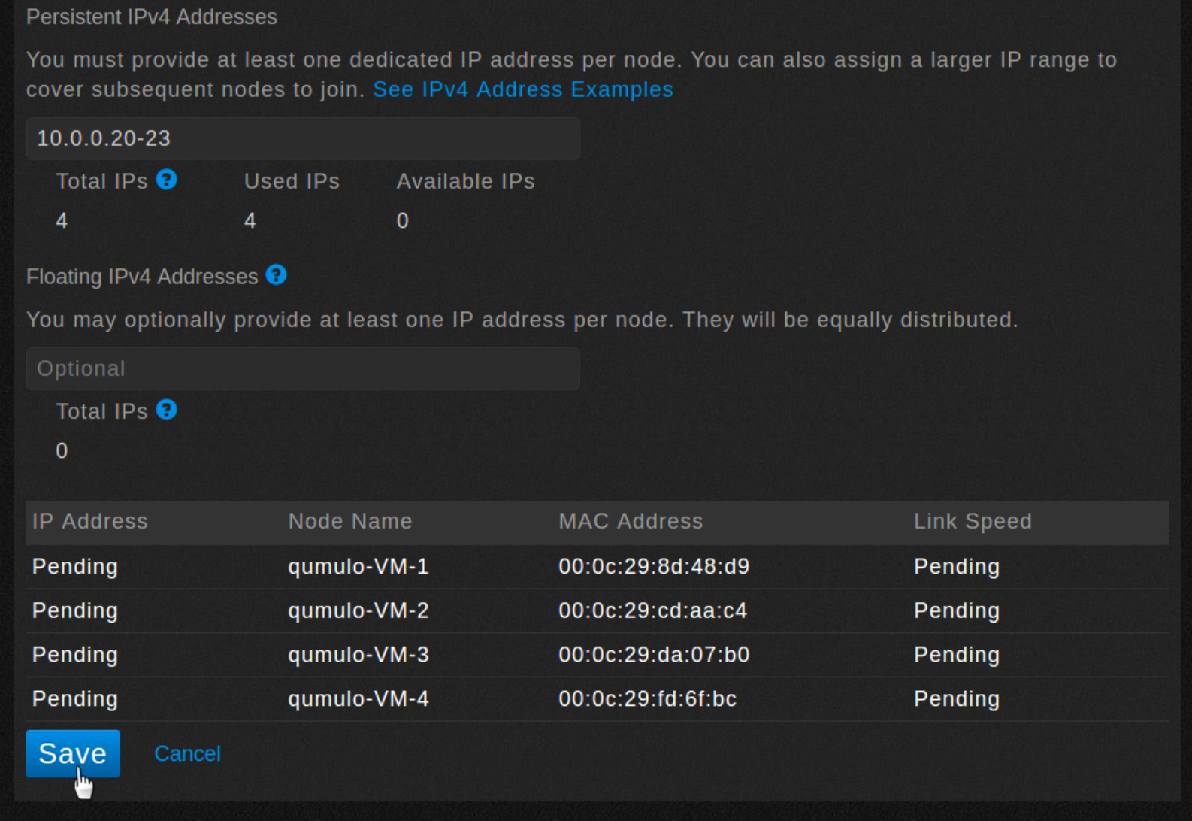

1. The following dialog box should appear.

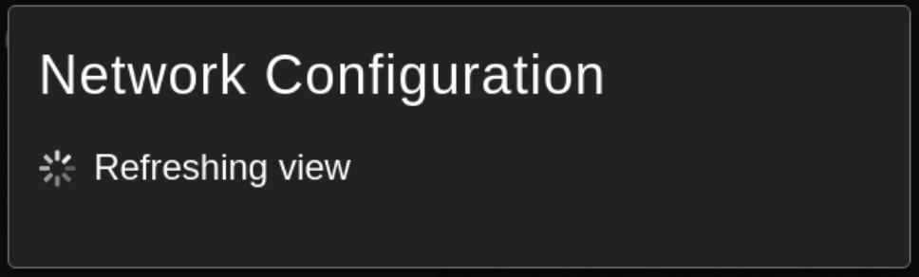

1. Static networking is now successfully configured. You can scroll down to see the configuration and each node’s IP address.

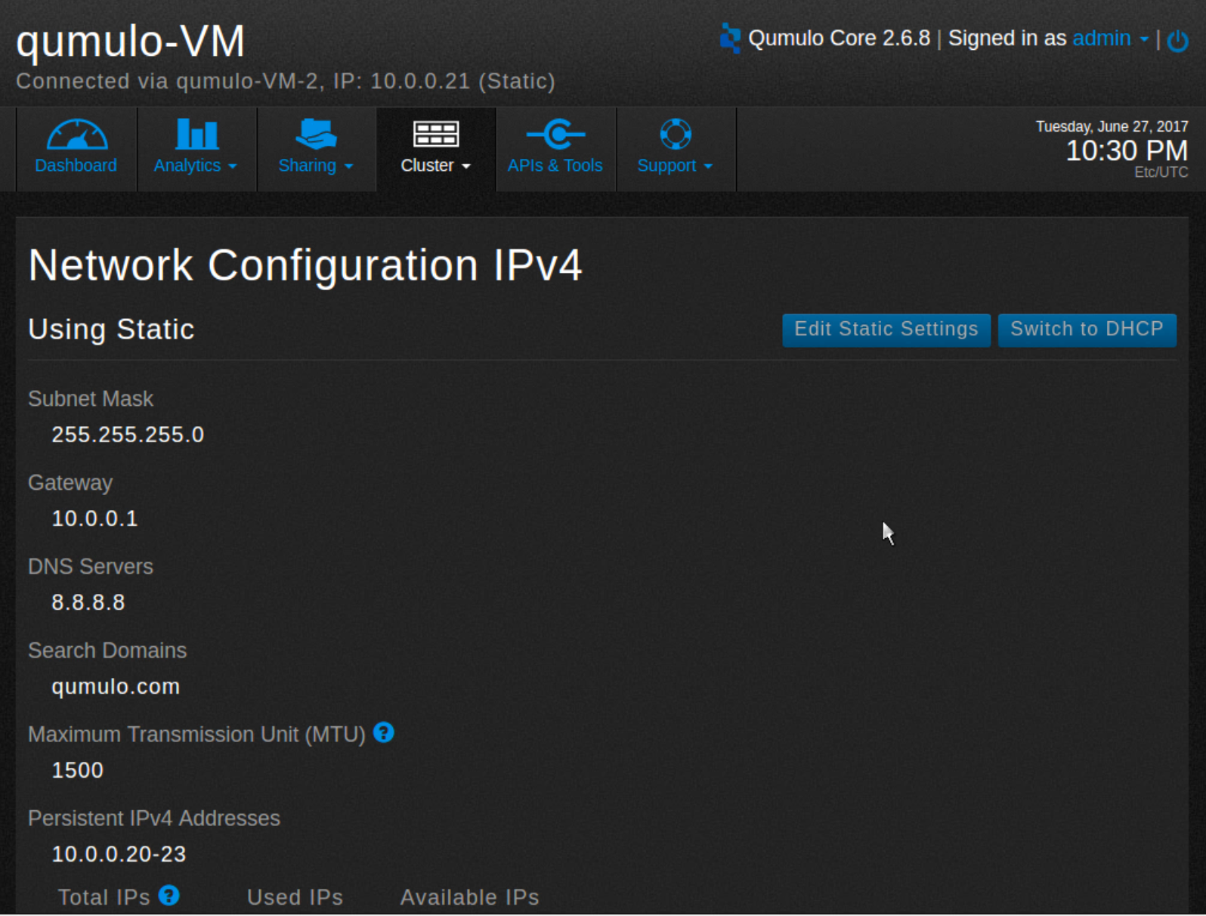

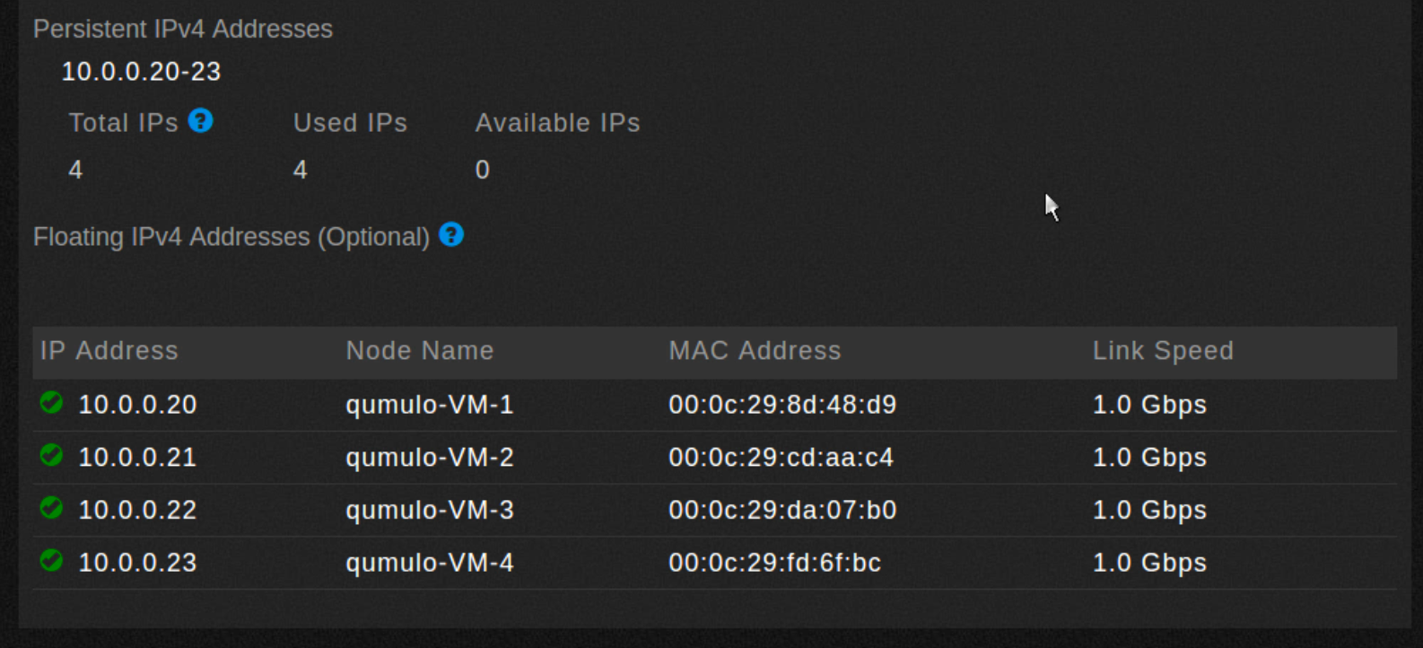

## What’s next?

The Qumulo cluster is now set up and ready to share data. The next step is to create shares and exports. You can either do this with either the Network File System (NFS) protocol or the Server Message Block (SMB) protocol.

Create an NFS export

Create an SMB share